Home

Welcome!

Welcome to the Cornell Tech Library Services Career Guide!
We work with the Career Management team at Cornell Tech to teach you how to find information on companies and industries so you can
- stand out in your interviews
- create lists of potential companies where you may want to work
- find company SWOTs and reports
- save time locating the information you need
...just to name a few of our career research services. We also support information needs for your new startup. Use this page to explore career resources, prepare for interviews, and research companies.

Email Us
We offer support via email and consultations. Write to library@tech.cornell.edu and we'll respond within one business day.

Top Databases
- PitchBook
Private equity and venture capital database. Find real time data on deals, identify and analyze comparables, and search investor details. Users must create an account using your Cornell email address. Log in > Log in with SSO > [Cornell email address]. Learn more
- Capital IQ
Capital IQ is a major financial platform used to find data on public and private companies, investment firms, capital transactions, and people. It includes financials for over 88,000 public companies and 825,000 private companies.
- Frost & Sullivan
In-depth market research and strategy reports covering technology, transportation, industrial processes, energy, IT, and more.
- IBISWorld
IBISWorld provides industry research reports and profiles for over 700 United States industries as well as a wide range of industries in Canada and China.

Newspapers
- Financial Times - Cornell students, faculty, and staff should create an account with your Cornell email address. Mobile apps are available to use in conjunction with your account.
- New York Times - Access articles from the New York Times via Factiva. L.L.M. students please contact the Law Library for access.
- Wall Street Journal - Cornell students, faculty, and staff should create an account with your Cornell email address. Mobile apps are available to use in conjunction with your account.
- >> More news and industry reads

Have a question?
Need help? Email library@tech.cornell.edu.
Additional help information on the Cornell Tech Library Services Website

Feedback
How can we make things better for you?
Submit suggestions & feedback

Exploration and Networking

Career Exploration
Get help from librarians! Our expertise can save you time finding excellent information to meet your career research needs. Email library@tech.cornell.edu.
Here are some examples of how we can help:
- Creating lists of employers with databases like Capital IQ, PitchBook, GuideStar Premium, and Mergent Intellect.
- Learning about different industries with reports and topic overviews from resources like IBISWorld, Frost & Sullivan, and Mergent First Reports.
- Exploring career paths and "day in the life" articles
- Finding reliable information beyond library resources, for example via trade associations or reports
- Showing you how to combine information in LinkedIn with other library resources in a structured search to expand your network and access to job openings.

Networking
New to networking or skeptical about whether it's really useful? Want to know more about how networking works in the United States?
The library can help you find information about what networking is, how it can benefit you, and how to improve your networking skills.
The library can also show you how to effectively navigate LinkedIn to find professional connections related to your interests and expand the opportunities you can access in your job search.
There are a few articles that might provide good starting points in the Harvard Business Review, Fall 2022 special issue:
- A Five-Week Guide to Getting a Job
- How to Find a Great Job Using the Strength of Your Weak Ties
- How to Network Across Cultures
- What to Say When You're Reaching Out to Someone on LinkedIn
- Learn to Love Networking
- How to Ask for an Email Introduction
Access Harvard Business Review in Business Source Complete. Then search for specific articles using the "Search within this publication" link at the top. You can also browse the entire issue using the menu of dates under All Issues and Articles > 2022 > Fall2022 Special Issue. Email library@tech.cornell.edu if you have any questions.

Connecting with Alumni on CUeLinks
CUeLinks is Cornell's university-wide online networking platform. Connect with Cornell alumni, peers, faculty/staff and friends of Cornell to explore and achieve your academic, career, and personal goals.

Core Resources
Here’s a short list of all the core library resources we most frequently recommend for career research.
Career Planning
- Vault – The Vault Guides to Jobs series is ideal for learning about careers and industries. Get information on the work environment, education requirements, a typical day in the life, and career outlook. Use when you are job hunting or looking for a tool to help you manage your career.
Company Profiles
- Capital IQ – Use the company “tear sheet” feature
- Factiva – Download custom company reports with a summary, financials, key developments, new products, and news articles.
Industry Insights
- IBISWorld – Use when you need either full reports or one-page snapshots on industries in Canada, China, and the United States. Reports include industry performance, outlook, major companies, supply chain, demand drivers, cost structure, barriers to entry, and key statistics.
- Frost & Sullivan – In-depth market research and strategy reports with European and global coverage of emerging technologies, including B2B spaces and growth opportunities.
- Technavio – Use Technavio when researching emerging and niche industries such as specialty chemicals, materials, health care, IT, energy, and more. Users can download up to 20 reports a month.
- Mergent Intellect – Navigate to the First Research reports to learn more about the industries that interest you. The Call Prep and Executive Insights sections are useful to prepare questions for both informationals and interviews.
Company News
- Get articles via Factiva or Nexis Uni (aka LexisNexis). Both contain thousands of full-text newspapers and business periodicals; you may be able to locate articles which quote company officials discussing the firm's finances.

Classic Career Books
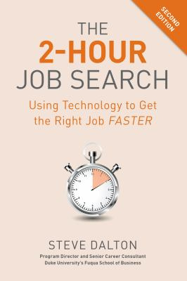The 2-Hour Job Search; 2nd edition by Steve Dalton
Call Number: Online
ISBN: 9781984857293
Publication Date: 2020
Outlines a systematic approach for securing the first interview with a potential employer.
Never Eat Alone by Keith Ferrazzi; Tahl Raz
Call Number: Online
ISBN: 9780385346665
Publication Date: 2014
A guide to the art of networking reveals the fundamental principles of what it takes to build lasting, mutually beneficial relationships.
Never Eat Alone by Keith Ferrazzi; Tahl Raz
Call Number: Online (2nd copy)
ISBN: 9780385346665
Publication Date: 2014
A guide to the art of networking reveals the fundamental principles of what it takes to build lasting, mutually beneficial relationships.
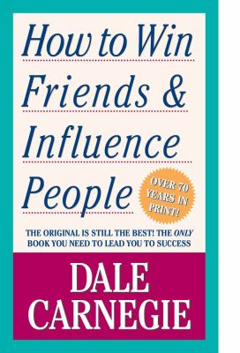How to Win Friends and Influence People by Dale Carnegie
Call Number: BF637.S8 C37 2010
ISBN: 9781439199190
Publication Date: 2010-04-27
Best-selling guide to interpersonal relationships provides suggestions for successfully dealing with people both in social and business situations.
More books to explore in the Engineering Library's Diversity STEM Resources

Book Delivery
Did you know you can get books delivered to you at Tech?
You can request print books from the Cornell University Library catalog by selecting “Request” in the book record. Select “Cornell Tech” for the campus delivery location. When the book arrives, it can be picked up at the Bloomberg Center security desk. Your book may also be returned at the Bloomberg Center security desk.
- Learn more about book access and delivery.
- Email library@tech.cornell.edu if you have any questions.

Startups and Entrepreneurship

Startups and Student Founders
Startups often have specialized information needs that require additional resources and search strategies. The library is here to help connect you to the information you need and save you time. We encourage you to schedule a one-on-one consultation with a member of our research team.
Email library@tech.cornell.edu to get a walk-through of any library resources or find out how the library can support you.
We are always happy to meet via Zoom and to address any questions you may have.

PitchBook

PitchBook
- Pitchbook provides data covering the private equity space. Includes information on thousands of private equity and venture capital deals, investors, funds, LPs, and more.
- Official source of data for the National Venture Capital Association.
- Use PitchBook to establish benchmarks, find real time data on deals, identify and analyze comparables, and search investor details.
- Use your Cornell email to log in with SSO.

Top Library Resources

Industry Insights
- Frost & Sullivan – In-depth market research and strategy reports with European and global coverage of emerging technologies, including B2B spaces and growth opportunities.
- Technavio – Use Technavio when researching emerging and niche industries such as specialty chemicals, materials, health care, IT, energy, and more. Users can download up to 20 reports a month.

Market Research
- Mintel Reports – Use when you need detailed market research from a variety of sectors, including consumer goods, travel and tourism, financial industry, internet industry, retail, and food & drink. You will need to create an account using your Cornell email address.
- IBISWorld – Use when you need either full reports or one-page snapshots on industries in Canada, China, and the United States. Reports include industry performance, outlook, major companies, supply chain, demand drivers, cost structure, barriers to entry, and key statistics. You can get a good sense as to whether or not something is growing and the size of the companies involved.
- Mergent Intellect – Navigate to the First Research reports to learn more about the industries that interest you. The Call Prep and Executive Insights sections are useful to prepare questions for both informationals and interviews.

Competitors
- LSEG Workspace – Get industry reports with information on companies in your space including profiles, R&D expenses, business segments, and SWOT analyses.
- Capital IQ – Use the powerful screening and charting features to create a list of competing firms or sizing your potential market. Pull financials on firms, deals, and markets.

Venture Capital Research
- PitchBook – Explore who is being funded, what types of technologies there are, news on the topics, as well as research reports. Includes investor and funds screening, market maps, emerging spaces, market analysis with analyst curated verticals. Official source of data for the National Venture Capital Association. Use your Cornell email address with the Log in with SSO option.
- Note: Downloads are capped at 10 a day or 25 a month. Whichever is less. Accounts are purged each year on May 30th. Eligible users need to create a new account to regain access.

Associations
Professional and industry associations can be valuable sources of information. For example, when you need to find participants for customer discovery interviews, or to build a sales list or competitors list. Associations also publish reports and articles on topics of interest to their members, and these are sometimes available for free.

Smarter Search Tips

Advanced Search in Google
- Limit the site search to government and non-profit organizations using the keywords site:.gov or site:.org.
- Use the keyword filetype:pdf to restrict your results to PDFs only. This often helps surface high-quality sources like whitepapers and reports.
- Combine these tips to help you understand what associations, non-profits in the space, and researchers think about the space.

Google Scholar Results in the Cornell Library
In Google Scholar, go to Settings > Library Links and add Cornell University to your search. This will bring up links to the articles you have access to as a Cornell user. Install Access Anywhere to more easily connect to resources when you're away from the Tech campus.

Entrepreneurship at Cornell List Serve
Link to join the email list: https://eship.cornell.edu/listserv/

Additional Resources
Library of Congress Small Business Hub: A Research Guide for Entrepreneurs

Books to explore
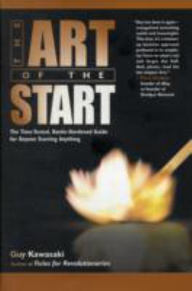The Art of the Start by Guy Kawasaki
Call Number: ILR Library, HD62.5 .K38 2004
A new product, a new service, a new company, a new division, a new anything - where there's a will, Kawasaki shows the way with his essential steps to launching one's dreams.
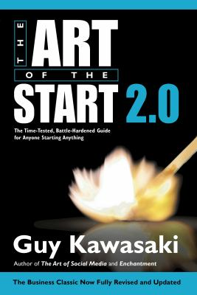The Art of the Start 2.0 by Guy Kawasaki
Call Number: Online
ISBN: 9780241972212
Publication Date: 2015
Fully revised and expanded for the first time in a decade, this is Guy Kawasaki's classic, bestselling guide to launching and making your new product, service, or idea a success.
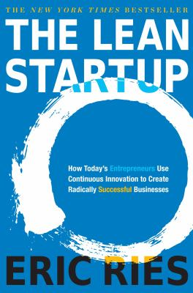The Lean Startup by Eric Ries
Call Number: Online, HD62.5 .R545 2011
ISBN: 0307887898
Most startups fail. But many of those failures are preventable. The Lean Startup is a new approach being adopted across the globe, changing the way companies are built and new products are launched.

Book Delivery
Did you know you can get books delivered to you at Tech?
You can request print books from the Cornell University Library catalog by selecting “Request” in the book record. Select “Cornell Tech” for the campus delivery location. When the book arrives, it can be picked up at the Bloomberg Center security desk. Your book may also be returned at the Bloomberg Center security desk.
- Learn more about book access and delivery.
- Email library@tech.cornell.edu if you have any questions.

Technical Roles

Technical Roles
The library resources on this page are for anyone seeking a technical role, such as software engineer, data engineer, data scientist/analyst, and more.
- Get help from our librarians! Our expertise can save you time finding excellent information to support your career research. Email library@tech.cornell.edu.

Core Library Resources
Here’s a short list of the library resources we most frequently recommend for career research

Career Planning
- Vault – The Vault Guides to Jobs series is ideal for learning about careers and industries. Get information on the work environment, education requirements, a typical day in the life, and career outlook. Use when you are job hunting or looking for a tool to help you manage your career.

Company Profiles
- Capital IQ – Use the company “tear sheet” feature
- Factiva – Download custom company reports with a summary, financials, key developments, new products, and news articles.

Industry Insights
- IBISWorld – Use when you need either full reports or one-page snapshots on industries in Canada, China, and the United States. Reports include industry performance, outlook, major companies, supply chain, demand drivers, cost structure, barriers to entry, and key statistics.
- Frost & Sullivan – In-depth market research and strategy reports with European and global coverage of emerging technologies, including B2B spaces and growth opportunities.
- Technavio – Use Technavio when researching emerging and niche industries such as specialty chemicals, materials, health care, IT, energy, and more. Users can download up to 20 reports a month.
- Mergent Intellect – Navigate to the First Research reports to learn more about the industries that interest you. The Call Prep and Executive Insights sections are useful to prepare questions for both informationals and interviews.

Company News
- Get articles via Factiva or Nexis Uni (aka LexisNexis). Both contain thousands of full-text newspapers and business periodicals; you may be able to locate articles which quote company officials discussing the firm's finances.

Interview Preparation
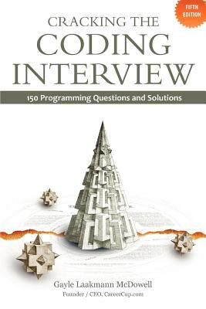Cracking the Coding Interview, 5th Edition by Gayle Laakmann McDowell
Call Number: QA76.6 .M3984 2014
ISBN: 9780984782802
Publication Date: 2011-08-22
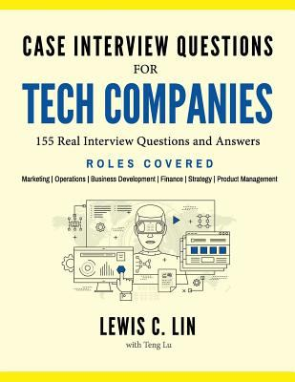Case Interview Questions for Tech Companies by Lewis Lin
Call Number: HF5383 .L563 2016
ISBN: 9780998120416
Publication Date: 2016-10-04

Resources for Building Technical Skills
- O'Reilly - O’Reilly has a collection of e-books and videos on computer programming, user manuals, and business and management topics.
- Skillsoft - All active students, faculty, and staff have access to Skillsoft's online learning and books through Cornell's enterprise account. Choose from thousands of courses, books, videos, and other resources to help you stay sharp. The following topics are represented: Analyst Research, Business Skills, Compliance, Desktop Skills, Engineering, Government, IT Skills, Well-being, and Certification. Learn more
- LinkedIn Learning - LinkedIn Learning offers 2,500 detailed courses with over 80,000 high-quality instructional videos on the latest software, creative, and business skills for people at all experience levels. Sign in with Single Sign-On. Use the www.cornell.edu domain if prompted. Learn more

Company Research for an Interview

Why do this?
Even if you're aiming for a technical role, you still need to be able to articulate why you want to work for the specific company where you're interviewing. The library can help you with finding the information you need to have a good understanding of the company and the industry overall.

To use your time efficiently, we recommend tackling these two areas first:

Review the company's website
  - If you're looking at a large publicly-traded company, take a look at their press releases and news section to better understand what they want you to know about the company. If they are a small startup and have an online presence, pay attention to the information they are sharing with the public. (If you have a few more minutes - For publicly traded companies, take a look at their quarterly (SEC 10Q) or annual reports (SEC 10K). For privately held firms, take a look at Pitchbook to learn more, including who is investing and how much).

How to quickly find SEC filings

Look up the company in Capital IQ. In the navigation menu on the left, go to News, Events & Filings > SEC Filings.

Research your industry space:
  - Read an industry profile in IBISWorld, Frost & Sullivan, or Technavio. First Research Industry Profiles are great because they provide you with Call Prep Questions. These can be found using Mergent Intellect > First Research.

Books to Explore
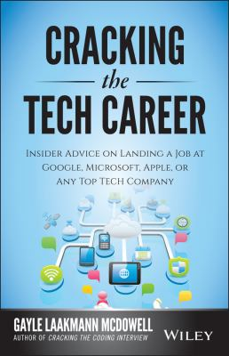Cracking the Tech Career by Gayle Laakmann McDowell
Call Number: HC79.H53 M33 2014
ISBN: 1118968085
Publication Date: 2014-09-15

Book Delivery
Did you know you can get books delivered to you at Tech?
You can request print books from the Cornell University Library catalog by selecting “Request” in the book record. Select “Cornell Tech” for the campus delivery location. When the book arrives, it can be picked up at the Bloomberg Center security desk. Your book may also be returned at the Bloomberg Center security desk.
- Learn more about book access and delivery.
- Email library@tech.cornell.edu if you have any questions.

Business Roles (including Product Manager)

Resources for Business Roles
Do you want to be a product manager, or work in strategy, operations, sales/marketing, or any other business role at a tech company? This page is for you!
- Get help from our librarians! Our expertise can save you time finding excellent information to support your career research. Email library@tech.cornell.edu.

Company Research for an Interview
Are you attending a networking session for a company you know little about and you have only 30 minutes to prep? Do you have a lead about a job opportunity and want to quickly check out what you can about the company?

When short on time, tackle these two areas first:

Review the company's website
If you're looking at a large publicly-traded company, take a look at their press releases and news section to better understand what they want you to know about the company. If they are a small startup and have an online presence, pay attention to the information they are sharing with the public. (If you have a few more minutes - For publicly traded companies, take a look at their quarterly (SEC 10Q) or annual reports (SEC 10K). For privately held firms, take a look at Pitchbook to learn more, including who is investing and how much).

How to quickly find SEC filings
Look up the company in Capital IQ. In the navigation menu on the left, go to News, Events & Filings > SEC Filings.

Research your industry space
Read an industry profile in IBISWorld, Frost & Sullivan, or Technavio. First Research Industry Profiles are great because they provide you with Call Prep Questions. These can be found using Mergent Intellect > First Research.

Interview Preparation

Books
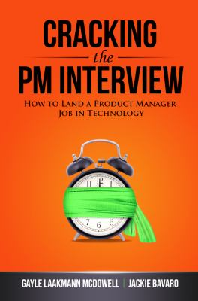Cracking the PM Interview by Gayle McDowell; Jackie Bavaro
Call Number: HF5415.15 .M335 2013
ISBN: 0984782818
Publication Date: 2013-12-01
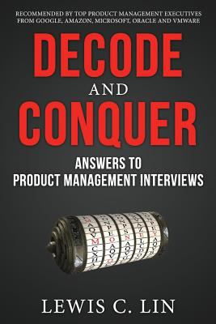Decode and Conquer by Lewis C. Lin
Call Number: HF5415.15 .L56 2013
ISBN: 0615930417
Publication Date: 2013-11-28
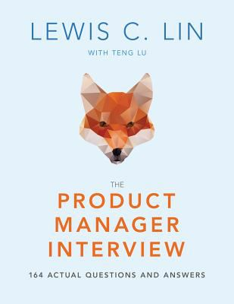The Product Manager Interview by Lewis Lin; Teng Lu (Contribution by)
Call Number: HF5415.15 .L565 201
ISBN: 9780998120447
Publication Date: 2017-11-06
This is the newer 3rd edition for the book formerly titled PM Interview Questions.
Case Interview Questions for Tech Companies by Lewis Lin
Call Number: HF5383 .L563 2016
ISBN: 9780998120416
Publication Date: 2016-10-04

Book Delivery
Did you know you can get books delivered to you at Tech? You can request print books from the Cornell University Library catalog by selecting “Request” in the book record. Select “Cornell Tech” for the campus delivery location. When the book arrives, it can be picked up at the Bloomberg Center security desk. Your book may also be returned at the Bloomberg Center security desk. Learn more about book access and delivery. Email library@tech.cornell.edu if you have any questions.

Resources for Building Skills
- LinkedIn Learning - LinkedIn Learning offers 2,500 detailed courses with over 80,000 high-quality instructional videos on the latest software, creative, and business skills for people at all experience levels. Sign in with Single Sign-On. Use the www.cornell.edu domain if prompted. Learn more
- Skillsoft - All active students, faculty, and staff have access to Skillsoft's online learning and books through Cornell's enterprise account. Choose from thousands of courses, books, videos, and other resources to help you stay sharp. The following topics are represented: Analyst Research, Business Skills, Compliance, Desktop Skills, Engineering, Government, IT Skills, Well-being, and Certification. Learn more

Core Library Resources
Here’s a short list of the library resources we most frequently recommend for career research.

Career Planning
- Vault -The Vault Guides to Jobs series is ideal for learning about careers and industries. Get information on the work environment, education requirements, a typical day in the life, and career outlook. Use when you are job hunting or looking for a tool to help you manage your career.

Company Profiles
- Capital IQ – Use the company “tear sheet” feature
- Factiva – Download custom company reports with a summary, financials, key developments, new products, and news articles.

Industry Insights
- IBISWorld – Use when you need either full reports or one-page snapshots on industries in Canada, China, and the United States. Reports include industry performance, outlook, major companies, supply chain, demand drivers, cost structure, barriers to entry, and key statistics.
- Frost & Sullivan – In-depth market research and strategy reports with European and global coverage of emerging technologies, including B2B spaces and growth opportunities.
- Technavio – Use Technavio when researching emerging and niche industries such as specialty chemicals, materials, health care, IT, energy, and more. Users can download up to 20 reports a month.
- Mergent Intellect – Navigate to the First Research reports to learn more about the industries that interest you. The Call Prep and Executive Insights sections are useful to prepare questions for both informationals and interviews.

Company News
- Get articles via Factiva or Nexis Uni (aka LexisNexis). Both contain thousands of full-text newspapers and business periodicals; you may be able to locate articles which quote company officials discussing the firm's finances or other important developments.

Creating Lists of Companies
These are some of the core resources that will let you create a list of companies that match criteria you specify.
- Capital IQ
Capital IQ is a major financial platform used to find data on public and private companies, investment firms, capital transactions, and people. It includes financials for over 88,000 public companies and 825,000 private companies.
- Foundation Directory
Use to create a list of public and private foundations in the U.S.
- GuideStar Premium
Searchable directory that provides detailed information on more than 850,000 nonprofit (501) organizations.
- Leadership Connect
Formerly Leadership Library, Leadership Connect allows searching and browsing within individual directories or across all directories using single or multiple criteria, such as name, job title, industry, and geographical location.
- PitchBook
Use when you're looking for information on startups and private companies. Users must create an account with your Cornell email address. Log in > Log in with SSO > [Cornell email address]. Learn more
- Uniworld
The authoritative source of information on multinational firms operating around the world. Can be searched by country, region, state, keyword, zip code or postal code, industry code, revenue and number of employees.

Books to Explore

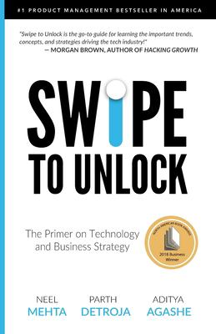Swipe to Unlock by Parth Detroja; Neel Mehta; Aditya Agashe
Call Number: QA76 .M44 2018
ISBN: 1976182190
Publication Date: 2017-09-20
Cracking the Tech Career by Gayle Laakmann McDowell
Call Number: Online
ISBN: 1118968085
Publication Date: 2014-09-15
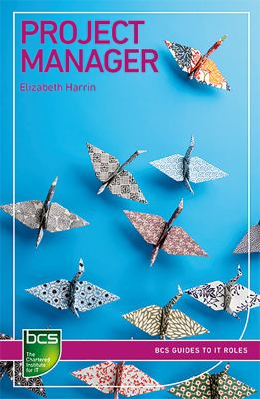Project Manager by Elizabeth Harrin
Call Number: Online
ISBN: 9781780174174
Publication Date: 2018-07-20
This book is a highly accessible guide to being a project manager (PM), particularly a project manager working within an IT field.
More books about product management in the catalog

Consulting

Resources for Consulting Roles
Are you aiming to land a top consulting job? Explore the library resources on this page for job search tips and interview preparation.
Get help from our librarians! Our expertise can save you time finding excellent information to support your career research. Email library@tech.cornell.edu.

Company Research for an Interview
Are you attending a networking session for a company you know little about and you have only 30 minutes to prep? Do you have a lead about a job opportunity and want to quickly check out what you can about the company?

When short on time, tackle these two areas first:

Review the company's website
If you're looking at a large publicly-traded company, take a look at their press releases and news section to better understand what they want you to know about the company. If they are a small startup and have an online presence, pay attention to the information they are sharing with the public. (If you have a few more minutes - For publicly traded companies, take a look at their quarterly (SEC 10Q) or annual reports (SEC 10K). For privately held firms, take a look at Pitchbook to learn more, including who is investing and how much).

How to quickly find SEC filings
Look up the company in Capital IQ. In the navigation menu on the left, go to News, Events & Filings > SEC Filings.

Research your industry space
Read an industry profile in IBISWorld, Frost & Sullivan, or Technavio. First Research Industry Profiles are great because they provide you with Call Prep Questions. These can be found using Mergent Intellect > First Research.

Interview Preparation
CQ Interactive
CQ Interactive, a companion to the Case in Point books, provides practice case questions and interview guidance. It is ideal when preparing for case-based interviews.

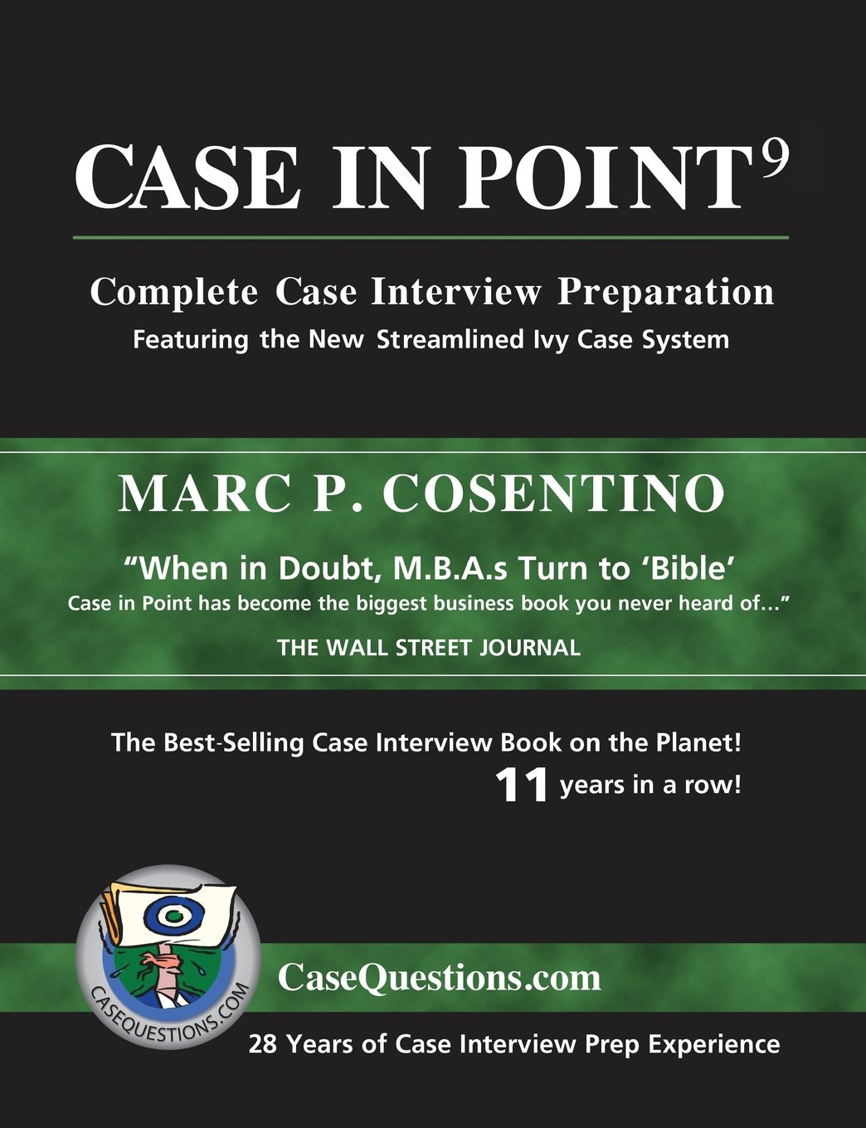Case in Point
Popular casebook by Marc Cosentino, Office of Career Services, Harvard University. Also see the online version "Case Questions Interactive": https://johnson.library.cornell.edu/database/cq-interactive/.
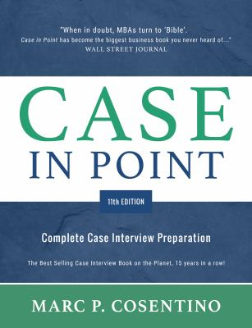Case in Point 11 by Marc P. Cosentino
Call Number: HD69.C6 C675 2020
ISBN: 9780986370762
Publication Date: 2020-06-01
Featuring the Ivy Case System - including a section on government and nonprofit cases.
Case in Point - Case Competition by Marc Cosentino; Kara Kravetz Cupoli; Jason Rife
Call Number: HF5718.22 .C67 2021
ISBN: 9780692114155
Publication Date: 2021
During interviews, you only have a short time to look at complex graphs, analyze them, extract what is important, and apply it to your answer. This book is designed to help you understand the role of graphs in consulting, introducing you to the Ivy Graph Framework, which will allow you to analyze 11 of the most popular graphs quickly and completely. Included are 10 cases with mulitple graphs allowing you to see how these cases unfold.
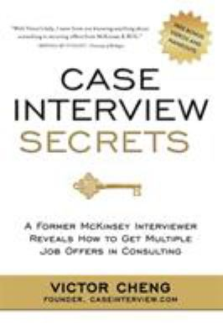Case Interview Secrets by Victor Cheng
Call Number: ILR HD69.C6 C43 2012
ISBN: 9780984183524
Publication Date: 2012-04-01
Victor Cheng, a former McKinsey management consultant, reveals his proven, insider's method for acing the case interview.
Embrace the Case Interview: Paperback Edition by Brad Schiller
Call Number: HD69.C6 S285 2014
ISBN: 9781494787264
Includes how to get the interview, behavioral interviewing, and the case interview itself.
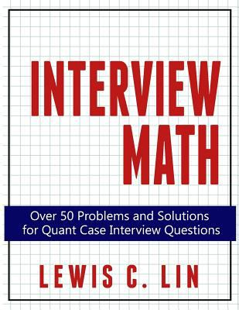Interview Math by Lewis Lin
Call Number: HF5549.5.I6 L56 2015
ISBN: 9780692361474
More than 50 practice problems and answers to help job seekers master quantitative interview questions including: Market Sizing Revenue Estimates Profitability Breakeven Pricing Customer Lifetime Value.
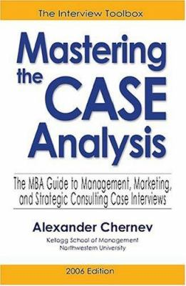Mastering the Case Analysis by Alexander Chernev
Call Number: HD30.4 .C48 2005
ISBN: 0976306131
Offers a systematic approach to analyzing business cases typically given in MBA job interviews.

Book Delivery
Did you know you can get books delivered to you at Tech? You can request print books from the Cornell University Library catalog by selecting “Request” in the book record. Select “Cornell Tech” for the campus delivery location. When the book arrives, it can be picked up at the Bloomberg Center security desk. Your book may also be returned at the Bloomberg Center security desk. Learn more about book access and delivery. Email library@tech.cornell.edu if you have any questions.

Core Library Resources
Here’s a short list of the library resources we most frequently recommend for career research.

Career Planning
- Vault -The Vault Guides to Jobs series is ideal for learning about careers and industries. Get information on the work environment, education requirements, a typical day in the life, and career outlook. Use when you are job hunting or looking for a tool to help you manage your career.

Company Profiles
- Capital IQ – Use the company “tear sheet” feature
- Factiva – Download custom company reports with a summary, financials, key developments, new products, and news articles.

Industry Insights
- IBISWorld – Use when you need either full reports or one-page snapshots on industries in Canada, China, and the United States. Reports include industry performance, outlook, major companies, supply chain, demand drivers, cost structure, barriers to entry, and key statistics.
- Frost & Sullivan – In-depth market research and strategy reports with European and global coverage of emerging technologies, including B2B spaces and growth opportunities.
- Technavio – Use Technavio when researching emerging and niche industries such as specialty chemicals, materials, health care, IT, energy, and more. Users can download up to 20 reports a month.
- Mergent Intellect – Navigate to the First Research reports to learn more about the industries that interest you. The Call Prep and Executive Insights sections are useful to prepare questions for both informationals and interviews.

Company News
- Get articles via Factiva or Nexis Uni (aka LexisNexis). Both contain thousands of full-text newspapers and business periodicals; you may be able to locate articles which quote company officials discussing the firm's finances or other important developments.

Resources for Building Skills
- LinkedIn Learning - LinkedIn Learning offers 2,500 detailed courses with over 80,000 high-quality instructional videos on the latest software, creative, and business skills for people at all experience levels. Sign in with Single Sign-On. Use the www.cornell.edu domain if prompted. Learn more
- Skillsoft - All active students, faculty, and staff have access to Skillsoft's online learning and books through Cornell's enterprise account. Choose from thousands of courses, books, videos, and other resources to help you stay sharp. The following topics are represented: Analyst Research, Business Skills, Compliance, Desktop Skills, Engineering, Government, IT Skills, Well-being, and Certification. Learn more

L.L.M. in Law, Technology & Entrpreneurship

L.L.M Career Resources
Please refer to the following resources for dedicated career research assistance for L.L.M. students:
- Law Career Management
- Law Library
- Cornell Tech Career Management

Industry Reads

Entrepreneurship at Cornell Email List
Follow this link to join the Entrepreneurship at Cornell email list: https://eship.cornell.edu/listserv/

News
- Wall Street Journal - Cornell students, faculty, and staff should create an account with your Cornell email address. Mobile apps are available to use in conjunction with your account.
- Financial Times - Cornell students, faculty, and staff should create an account with your Cornell email address. Mobile apps are available to use in conjunction with your account.
- New York Times - Access articles from the New York Times via Factiva. L.L.M students please contact the Law Library for separate instructions.
- Bloomberg BusinessWeek - Email us if you are looking for a new article that is not yet available.
- Library PressDisplay provides online access to more than 700 newspapers from more than 55 countries, displayed in their original format and accessible by country, language, or title.

Additional News Databases
- Business Source Complete - Full text articles for top scholarly business journals and other sources. >1,800 peer-reviewed publications. Includes the Harvard Business Review, Euromonitor, and Datamonitor.
- Factiva - Full-text online service for international news and business information. Covers over 28,000 sources in 23 languages in more than 150 countries. Some company and market research is included. Includes full-text coverage of the New York Times and Wall Street Journal.

Articles and Blogs
Here are a few additional resources for keeping up to date or learning more about the tech industry. Some may require an individual subscription for additional content.
- The Information
Articles covering the technology industry. Requires a subscription.
- Masters of Scale
Podcast hosted by Reid Hoffman covering company growth.
- Stratechery
Articles and podcasts analyzing the strategy and business side of technology and media, and the impact of technology on society.
- Techmeme
Aggregates articles on tech.
- Wired
Articles covering technology, business, and culture.
- Recode
Tech and business news.
- TechCrunch
Site dedicated to technology including start-ups, new products, and tech news.
- MIT Technology Review
- Not Impossible
Example of emerging tech site; great for idea generation.
- CIO
Targets CIOs and other IT leaders providing insight on tech trends and IT's role in achieving business goals.
- FT.com Technology Companies
Financial Times articles covering the tech space. Get your FT.com account using your Cornell email address (must first register using Cornell Univeristy Library's website instructions)
- NY Times Bits
Tech articles from NYTimes.

International Students and Global Jobs

International Students and Global Jobs
We compiled the resources on this page for international students looking for jobs in the US.
- Resources like Interstride and Uniworld may also be of interest to students who are looking for global job opportunities (careers outside the US).
- Please write to library@tech.cornell.edu to meet with a librarian and learn more about career research.

Cornell Resources
- Interstride – For international students and globally minded Cornellians to discover jobs and internships in the US and around the world. Find jobs and internships by work authorization and visa type and search for companies with a history of hiring international candidates. Connect with Cornell alumni based on your interests and goals.
- Uniworld – Use Uniworld to identify multinational companies that have offices in the US and overseas. As an international student, you can find companies with offices in both your home country and the US. Can also be used as a tool to find companies that operate outside the US if you are doing a global job search.

Additional resources
- MyVisaJobs.com – Identifies US firms that have previously sponsored visas.
- USCIS – Official government website for U.S. Citizenship and Immigration Services.

